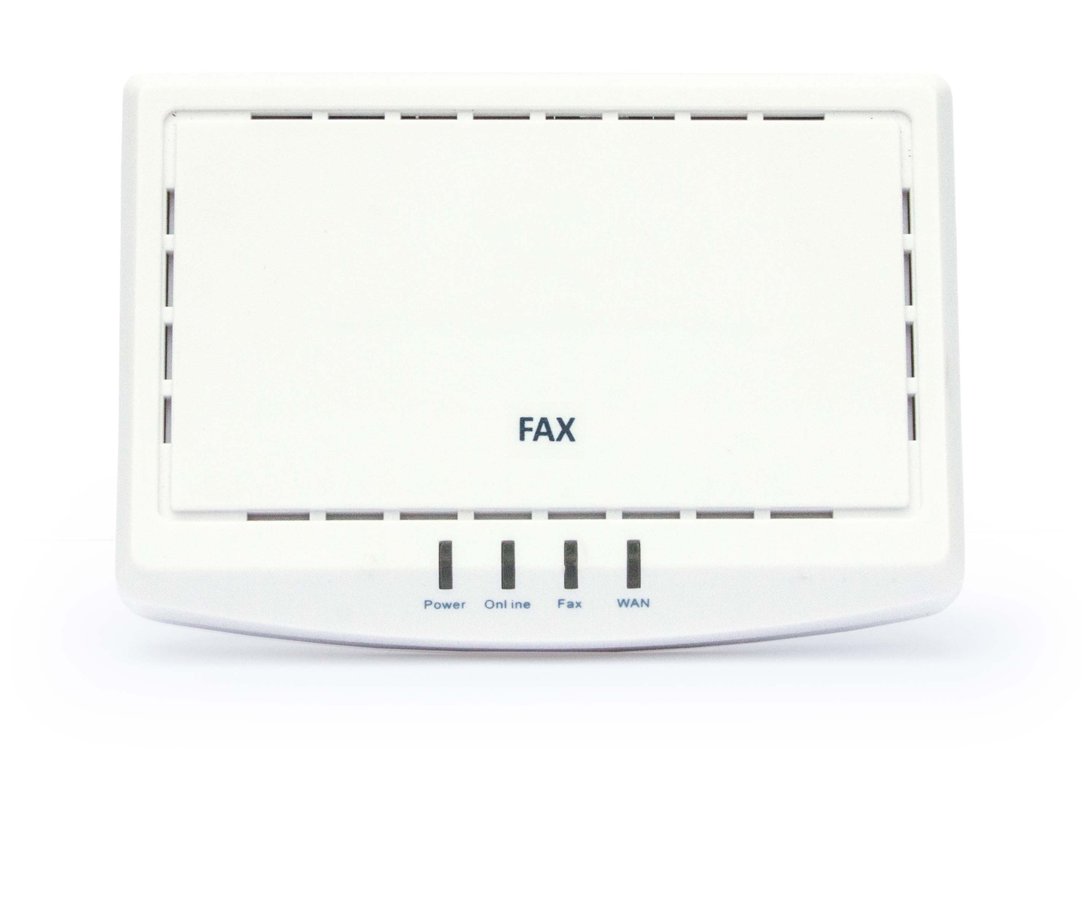

Fax to Fax (Internet Fax from end-user’s fax machine) provides a reliable and secure fax machine integration solution.

t.38 and Internet Faxing

t.38 the ITU recommended standard for sending and receiving faxes over the Internet, was designed to send raw data over networks for fax transmissions. In theory, this should work fine. The reality, as anyone that has tested t.38 over the public Internet can attest, is at best, unreliable. Jitter, packet loss and PCM Clock sync issues often cause these faxes to fail and the longer the fax, the more likelihood of failure. For businesses that rely on fax as an important way to communicate with their customers and business partners, it is clearly a costly, frustrating and unacceptable solution.

Fax to Fax Solution: Taking t.38 out of Internet Faxing

With the Internet Fax to Fax solution, end-users never need to worry about packet loss, jitter or PCM Clock sync issues creating fax failures. The Fax to Fax solution does not utilize t.38 at the end-user’s location. Rather, our Fax ATA (Analogue Telephone Adapter) is loaded with proprietary software essentially turning the ATA into a local fax machine accepting the fax from the end user’s fax machine locally, encrypting and compressing the fax data locally and transmitting the fax to the cloud. This process is not affected by jitter or packet loss and works perfectly well over the poorest of Internet connections including Wi-Fi and satellite.

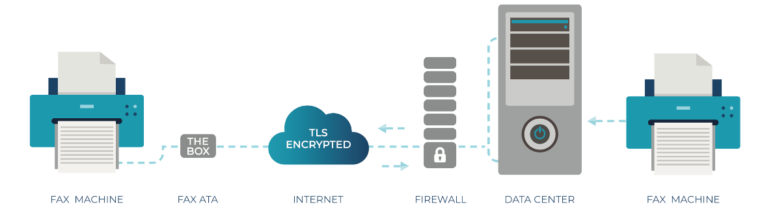

Once a fax a fax is received from the end user’s fax machine/ATA in whole at the Data Center, our Smart Routing will attempt to deliver the fax to its intended destination through a variety of ‘fax sensitive’ carriers employing auto-retries based on algorithms designed to give the highest delivery success rate possible in the shortest amount of time. Our success rate for fax delivery is higher than one would get with a standard POTS line connection. Confirmation is then sent to the end user via email and/or fax machine as to the result of the sent fax transmission (success/failure).

Incoming faxes, destined for the end user’s fax machine, work in the opposite direction. Incoming faxes are first received in whole at the Data Center where the end user’s Fax ATA connects securely over TLS encryption and then delivered to the end user’s fax machine. Incoming faxes can also be delivered to the end user’s email. If the end user’s fax machine or ATA is off-line or unable to receive, faxes can queue until such a time the ATA and fax machine are available, so senders never get a busy signal and end users never miss a fax!

